1. Where (which directory path) is your SOF file located, and what it is called
   1. Location of SOF **~/Cassiel_Jung_33294968_Lab_Lab1.zip/rtl/lab1_template_de1soc**
   2. Name of SOF

**Basic_Organ_Solution.sof**

1. What is the status of the lab (what works, what doesn't)
   1. Everything works. Frequency divider, the tone organ and LED light up from side to side
2. Annotated simulation screenshots as required by the lab
   1. clockDivisor

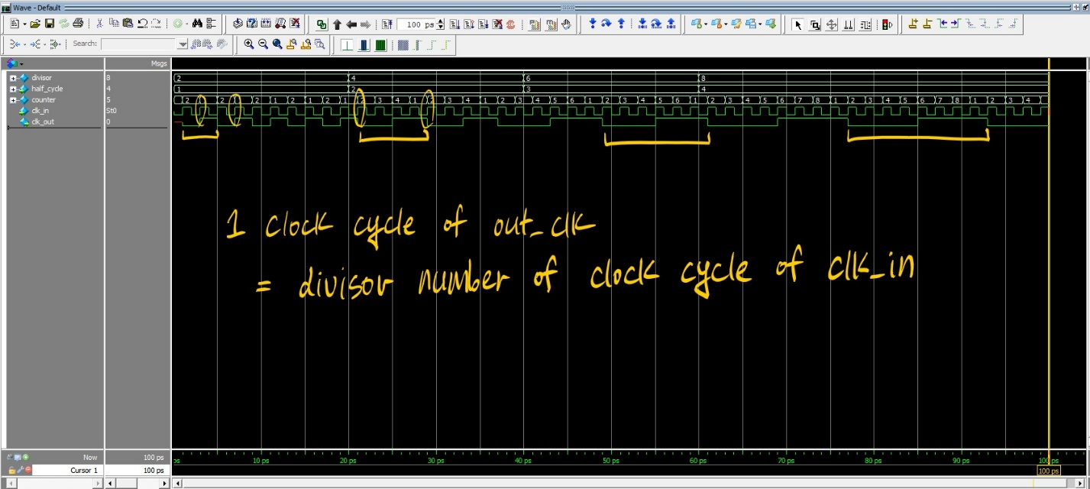

* 1. movingLED

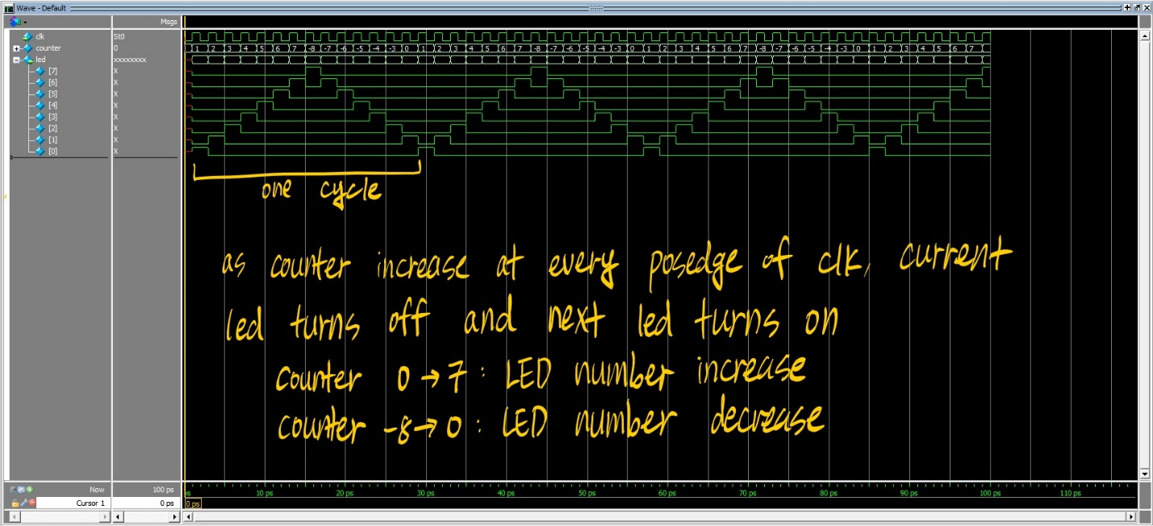

1. Annotated SignalTap screenshots as required by the lab

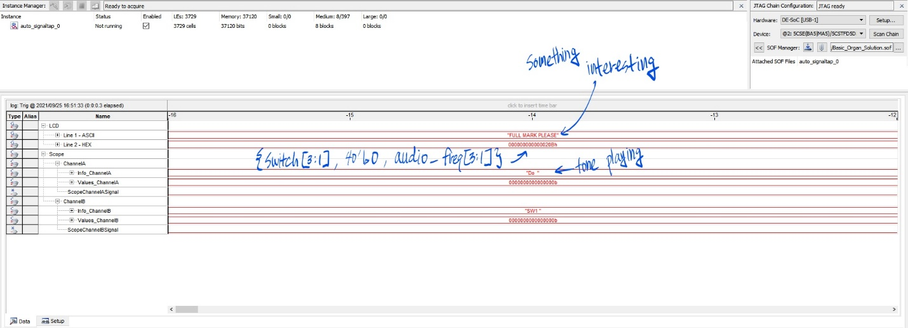

1. Information on how to run the simulations (i.e. where the files are located, which program you used to run your simulation)
   1. Simulation files are located at **~/Cassiel_Jung_33294968_Lab_Lab1.zip/sim**
   2. ModelSim was used.
   3. Steps
      1. Open project file named **lab1_simulation.mpf**
      2. Compile all
      3. Start simulation with **clockDivisor_tb.v** or **movingLED_tb.v**
      4. Load .do file of **clcokDivisor_wave_format.do** or **movingLED_wave_format.do**
      5. Run the simulation
2. Any additional information that would be relevant for the TA marking your project.
   1. Annotated images are included in **~/Cassiel_Jung_33294968_Lab_Lab1.zip/sim** as well